In the first lesson of JavaScript primitives where we talked about the 5 basic datatypes, which are string, number, Boolean, undefined & null. Here in this lesson we will learn in detail about Null & Undefined.

They are both just values of which a variable can be set to and they both mean nothingness in a sense, but there is a big difference between them. The code below illustrates that difference.

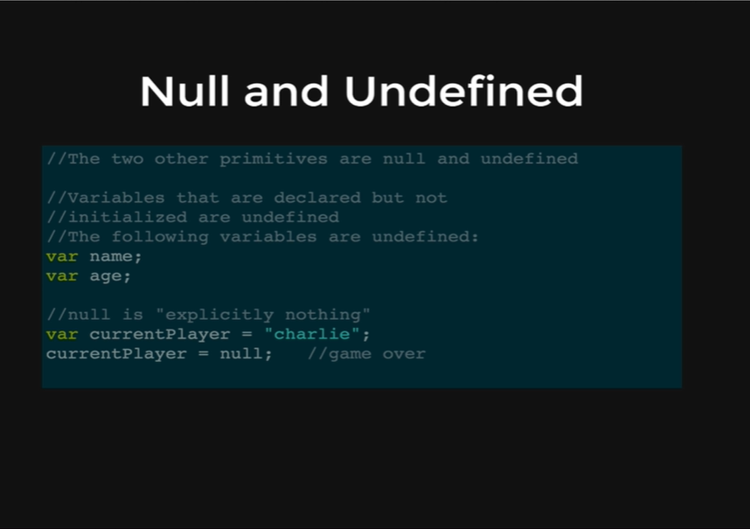

So, lets start with undefined, if we declare a variable like

var name;

but we do not set it to any value or strings, its declared but not initialized to a value, then its considered undefined.

Console coding:

var age;

age;

* Undefined

Null is another way of expressing nothingness, but its different because null means explicitly empty or explicitly nothingness, versus undefined which just means that something does not have a value yet.

So, on the picture, we are setting a current player variable as “charlie” in a game but then when the player dies, the current player variable is set to NULL, to make it explicitly clear that there is no current player.

Null and Undefined are similar, they both mean nothingness, but there is a big difference between them where NULL means explicitly nothing, versus Undefined something is empty or does not have a value yet.